Dr. Donald A. Cool

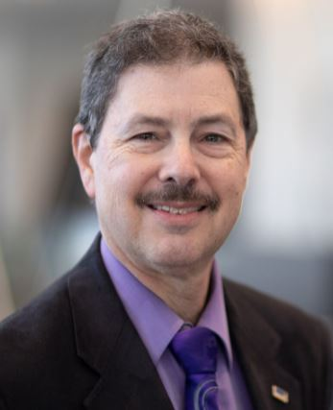
Dr. Cool received his B.S. degree in Biology from Houghton College in 1978. Studies included environmental biology and ecology, as well as minors in mathematics and physics. Graduate work at the University of Rochester School of Medicine and Dentistry resulted in Master’s and Doctorate degrees in Radiation Biology in 1981 and 1983 respectively.

Dr. Cool retired from the Electric Power Research Institute (EPRI) in December 2021. As a Technical Executive, he provided provided advice in radiation safety and protection and is actively involved in the EPRI program of work on low dose radiation effects.

Dr. Cool retired from the U. S. Nuclear Regulatory Commission (NRC) in July 2015 after nearly 33 years of service. He was the Senior Level Advisor for Radiation Safety and International Liaison in the Office of Nuclear Material Safety and Safeguards, and was responsible for coordinating a wide range of international activities related to radiation protection, safety and security of byproduct materials, decommissioning and waste management, radiation protection policy, and international standards. He had previously served in various senior management positions including Director, Division of Industrial and Medical Nuclear Safety, and other increasingly responsible positions within the NRC staff.

Dr. Cool has been a leader in radiation protection standards and guidance throughout his career, including revisions of the NRC Standards for Protection against Ionizing Radiation, development of the enhanced participatory process for involvement of stakeholders in regulatory products such as the Radiological Criteria for License Termination, and creation of the Consolidated Guidance About Materials Licensees (NUREG-1556 series). He was an active contributor to the revision of the International Basic Safety Standards for Protection Against Ionizing Radiation and for the Safety of Radiation Sources. Dr. Cool has also been frequently called upon to provide press interviews, Congressional briefings and testimony, and presentations to various scientific organizations, professional societies, and national and international conferences and symposia.

Dr. Cool’s involvement with the International Commission on Radiological Protection began in 1984 with the Task Group that developed ICRP Publication 46, Principles for the Disposal of Solid Radioactive Waste. Subsequently he was a member of the Task Groups which prepared Publications 64, 76, 96, 101a, 123, 124, and 125. He was a member of Committee 4 on Application of the Commission's Recommendations for a total 16 years. Dr. Cool was elected in October 2013 to Main Commission, and to the Chairmanship of Committee 4. In 2021 he was elected to the position of Vice-Chair of the Commission. Beginning in 2013, he is a Council Member of the U.S. National Council on Radiation Protection and Measurements. He has served on numerous panels and expert groups of the International Atomic Energy Agency and the Nuclear Energy Agency Committee on Radiation Protection and Public Health.

